

ITC-511 Application, Maintenance and Testing

Documentation of End Users Help (2019)

Dikshant Shrestha & Bhim | ITC-511 Group-5 | 03/04/2019

Submitted to David Cartman

Help Manual

1. How to setup easy appointments?
2. How to login to back-end section?
3. How to recover administrator profile password?
4. How to add new appointment in backend section?
5. How to add new providers in backend section?
6. How to edit details of your company’s name, mail and link?
7. How to add new services in backend section?
8. How to change password for administrator?
9. How to add new customers in backend section?
10. How to change personal details of administrator?
11. How to add break in back end section?
12. How to activate CAPTHA Option?
13. How to Setup working plan for the company?
14. How to change time and date in backend section?
15. How to receive notifications in backend section?
16. How to confirm your customer details saved on your data?
17. How to delete database from backend section?
18. How to edit your data from backend section?
19. How to log out from back end of easy appointments?
20. How to edit and save your cookie, terms and conditions and privacy policy?
21. How to change language in back end easy appointments?
22. How to add categories in easy appointments?
23. How to add unavailable period in back end section ?

Easy appointments Setup:

* Open IP server link from aws instance and click on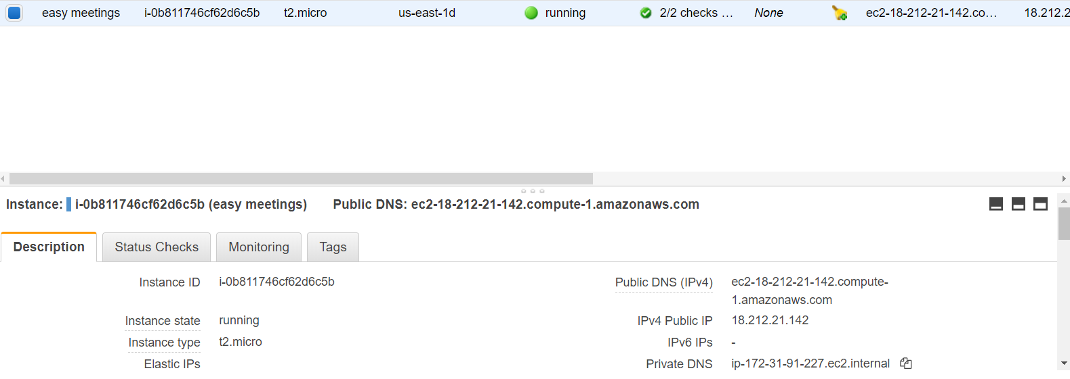
* <http://3.94.201.11/index.php/backend>
* Then you gain access towards Easy appointments.
* Fill the details

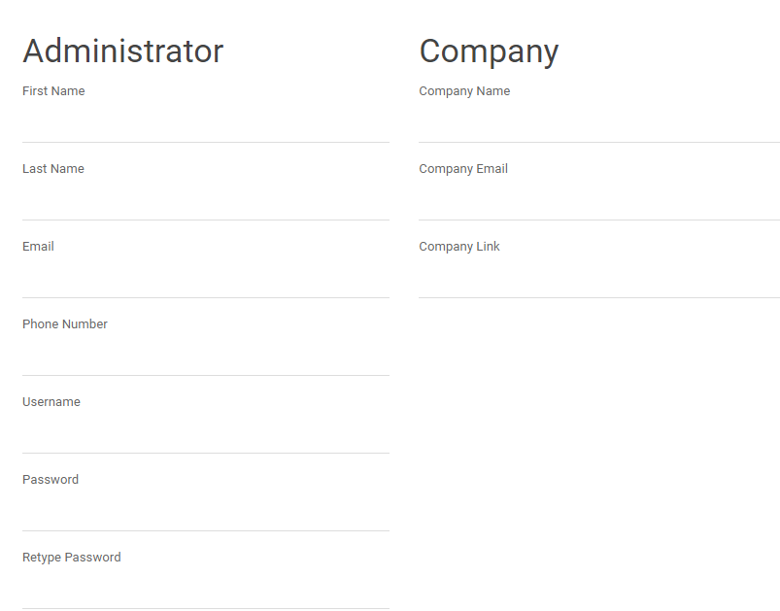

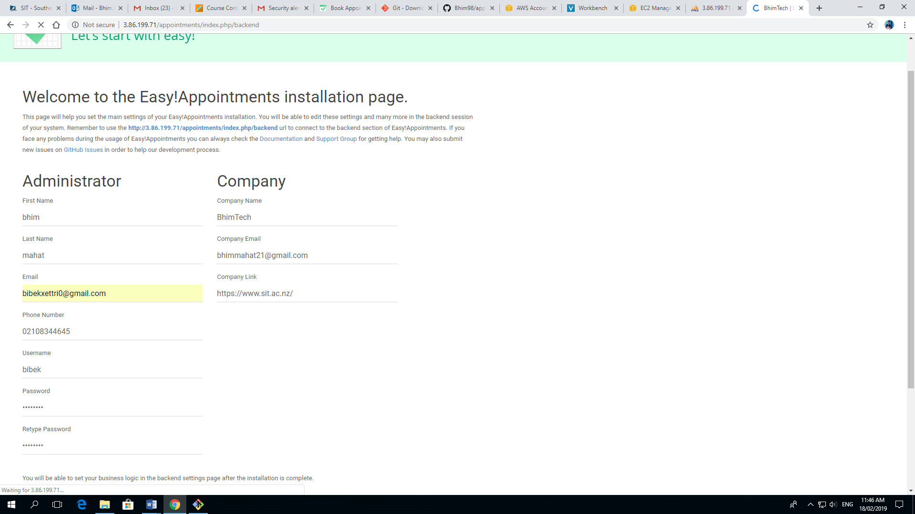

* After filling your details click on install easy appointments.

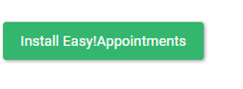

Booking page Steps:

* On this page, simply click on go to Booking page



* Select your provider and service and press next button.

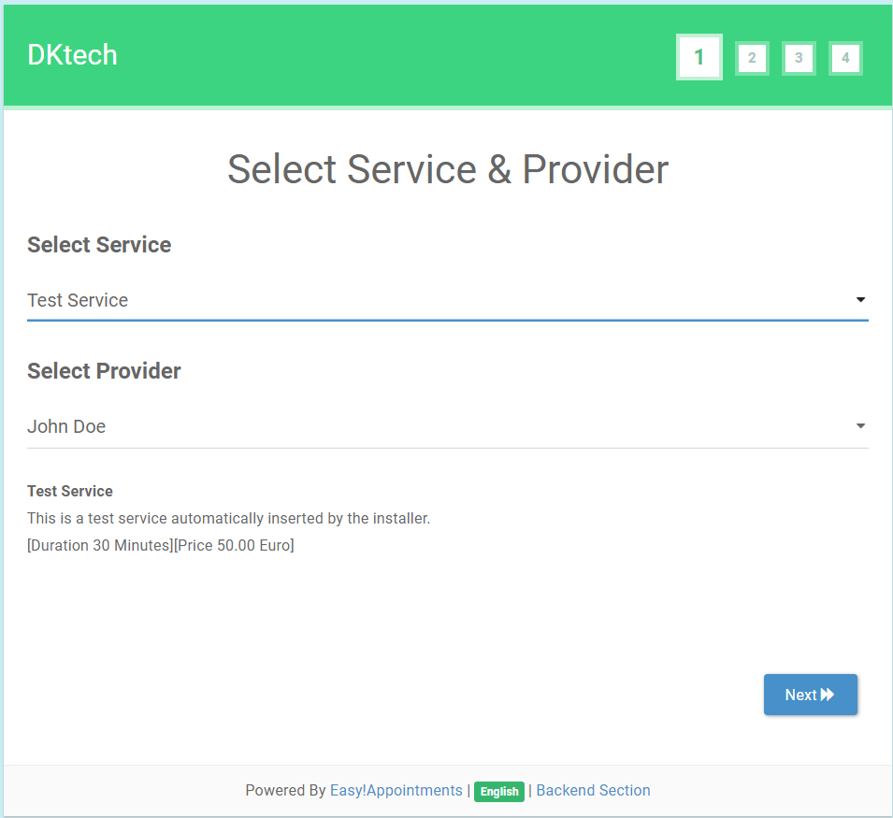

* And then choose date, calendar and time to get appointments and click next to other page.

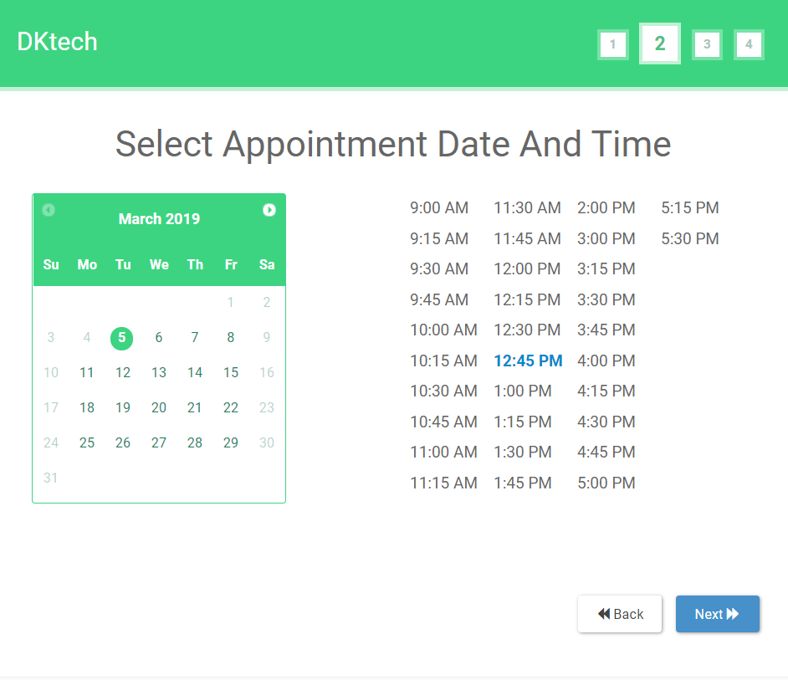

* In fill your information first name, last name, email and phone number are mandatory and click next

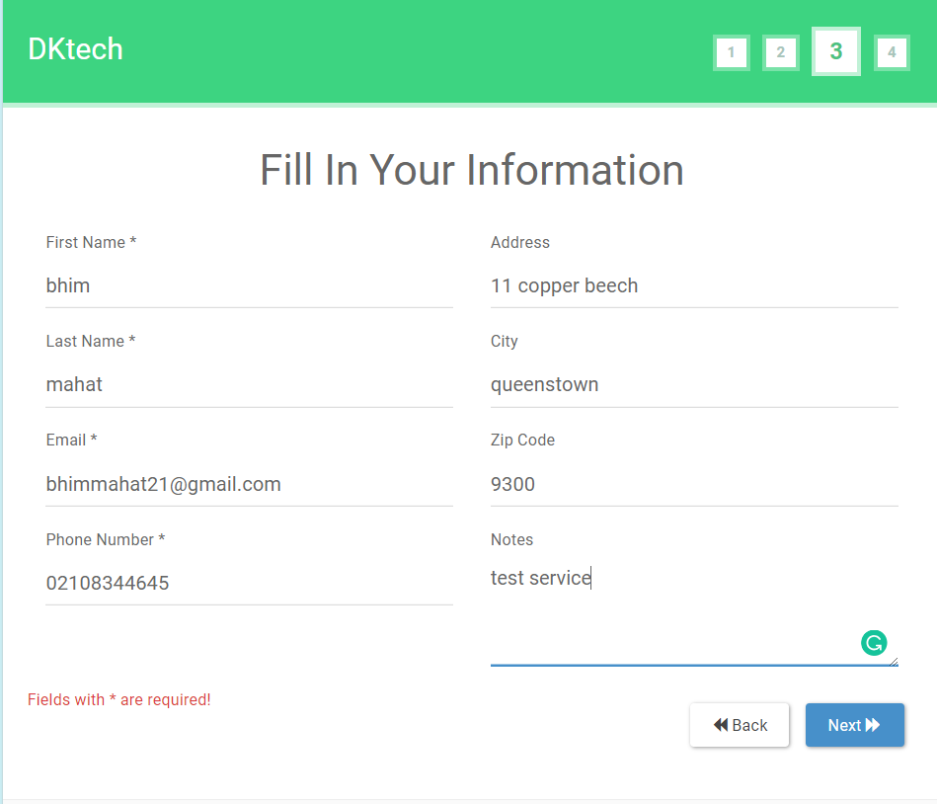

* At last page, check your details and check your time,date price and press confirm
* Now your appointment date is fixed

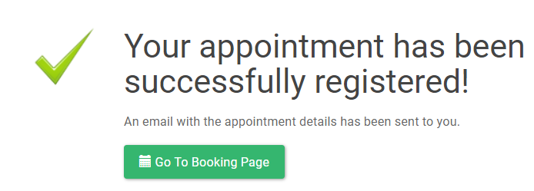

Question 2

-

Login to backend section

We open our Easy appointments in the web browser and then:

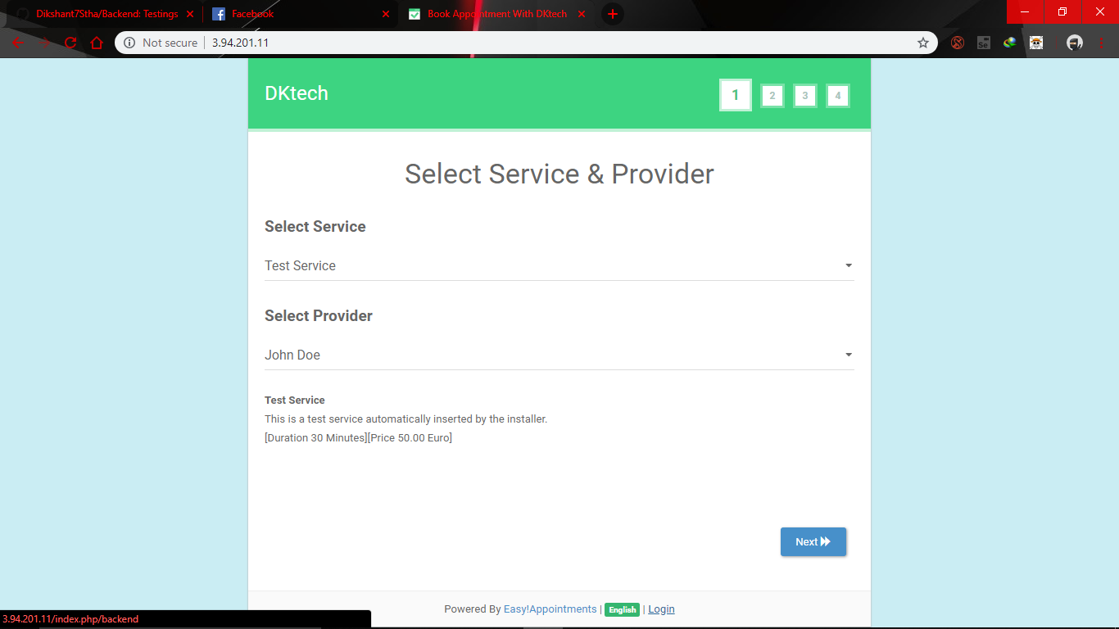

Firstly, we go to the login button at the bottom.

Then we will have the page like this:

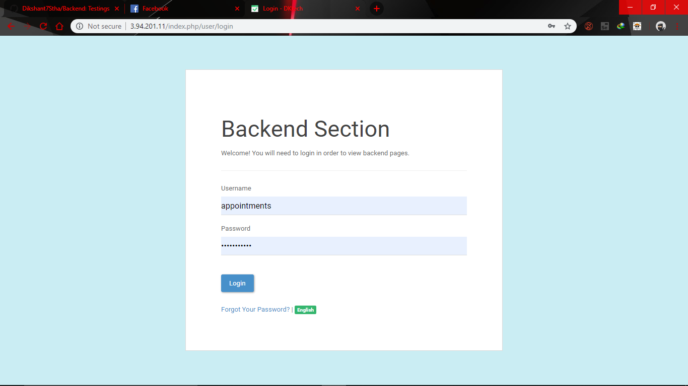

After that we will have a screen like this and we enter our user name and password and click on login.

Then we get in to the backend section.

Question 4

-

After u get in to the backend page then u will have a page like this :

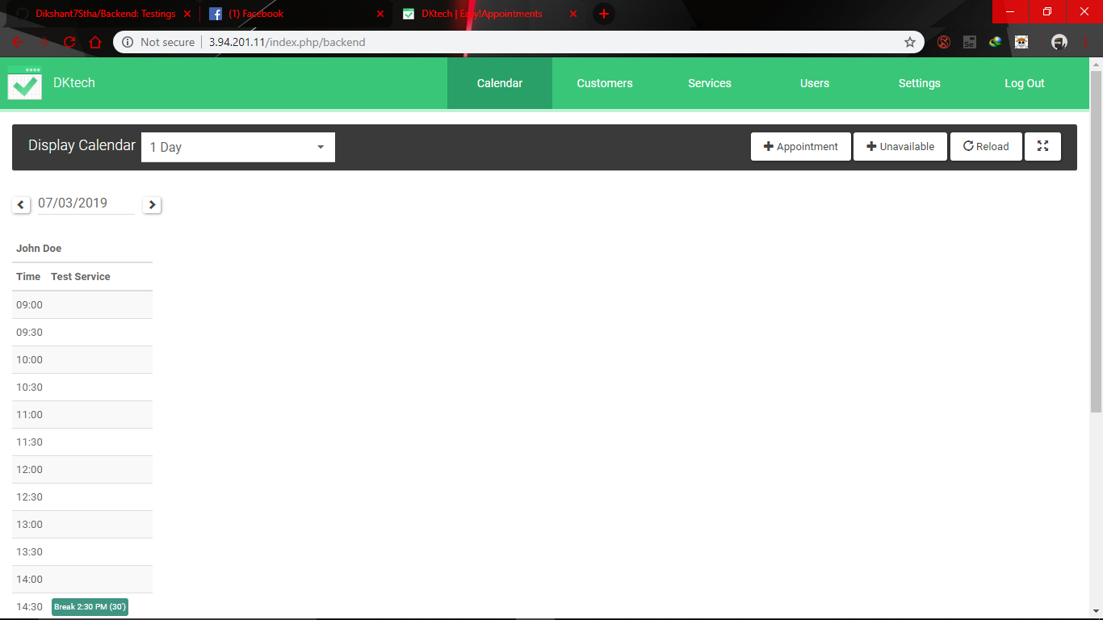

In this page we have + Appointment button we click on it

And we get an option like this

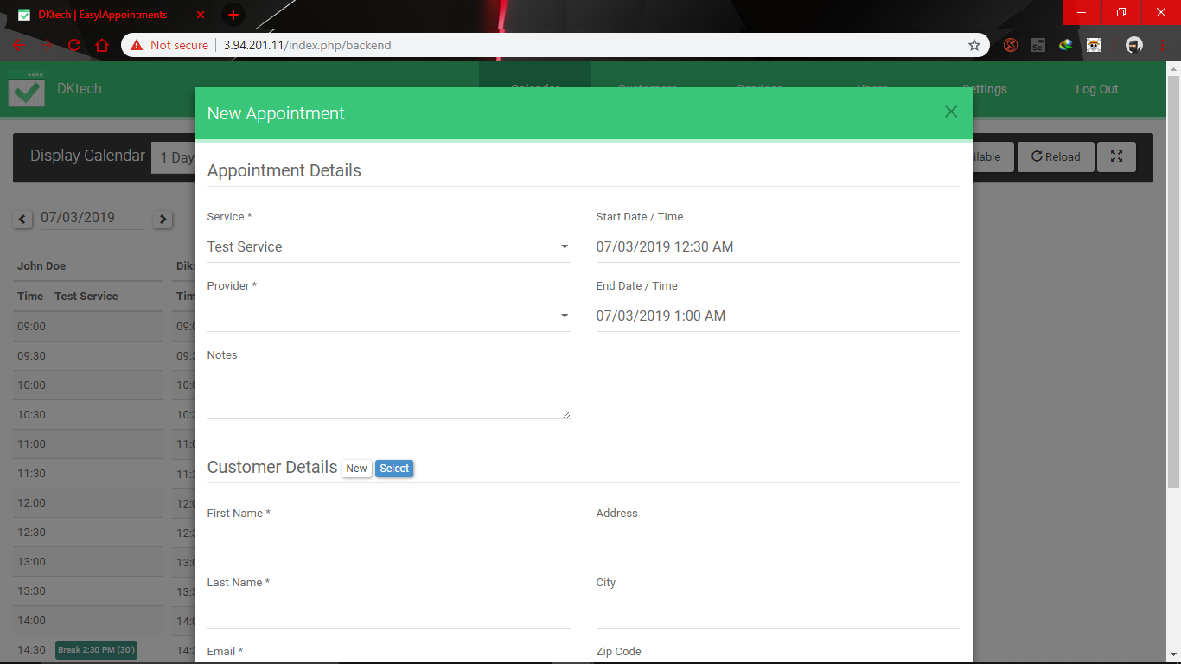

We fill everything on it and then press save then your appointment is booked.

Question 6

-

We change the company details in the section settings which is at the right top of the backend section.

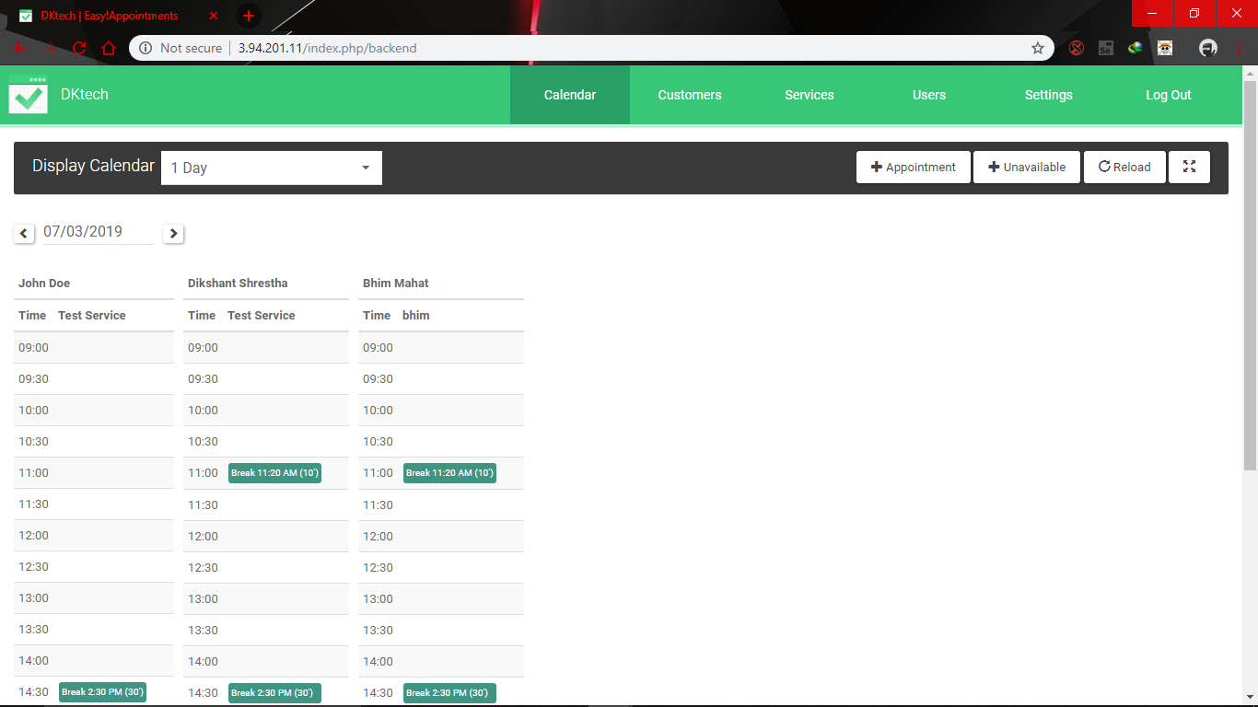

We click on it then we reach a page where we can edit our company details.

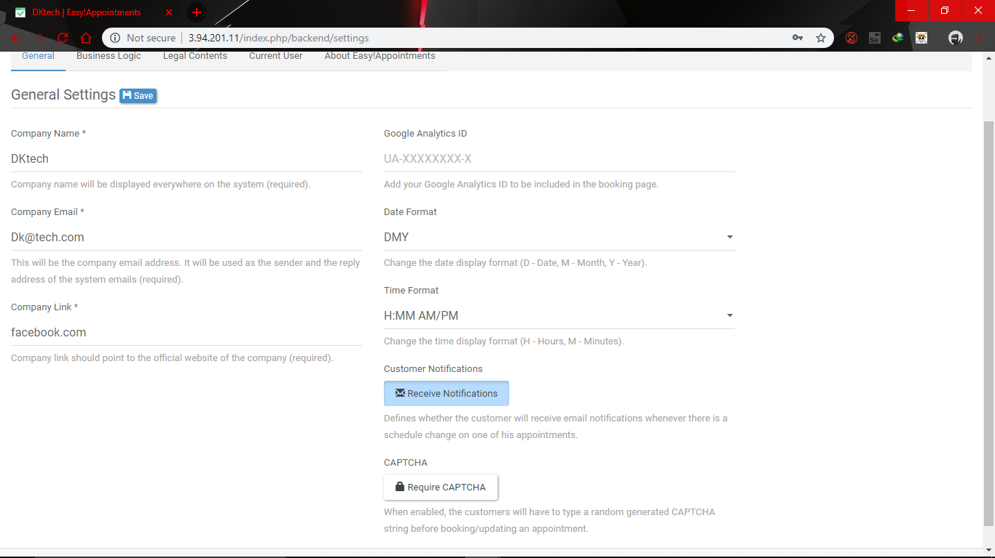

We can edit them on this page and press save to keep the change.

Question 8

-

We can change the password of the administrator from the menu settings

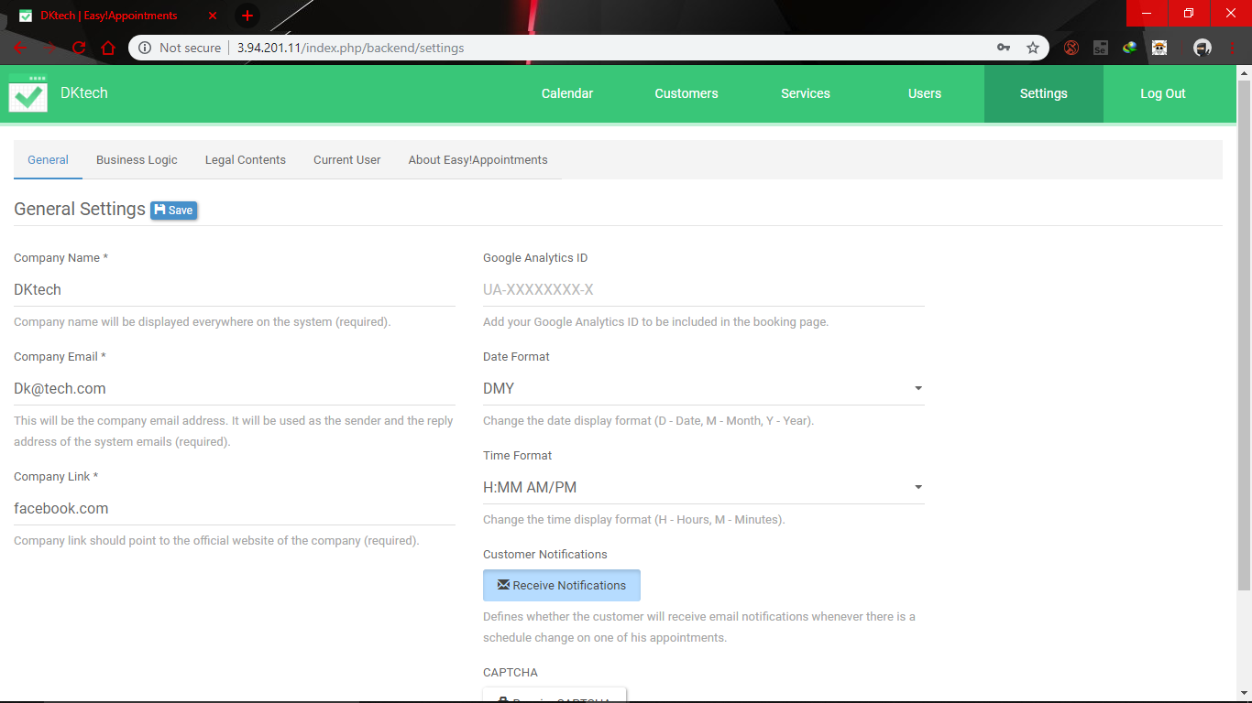

In the page we have a tab as Current customers in that page we have a view like this

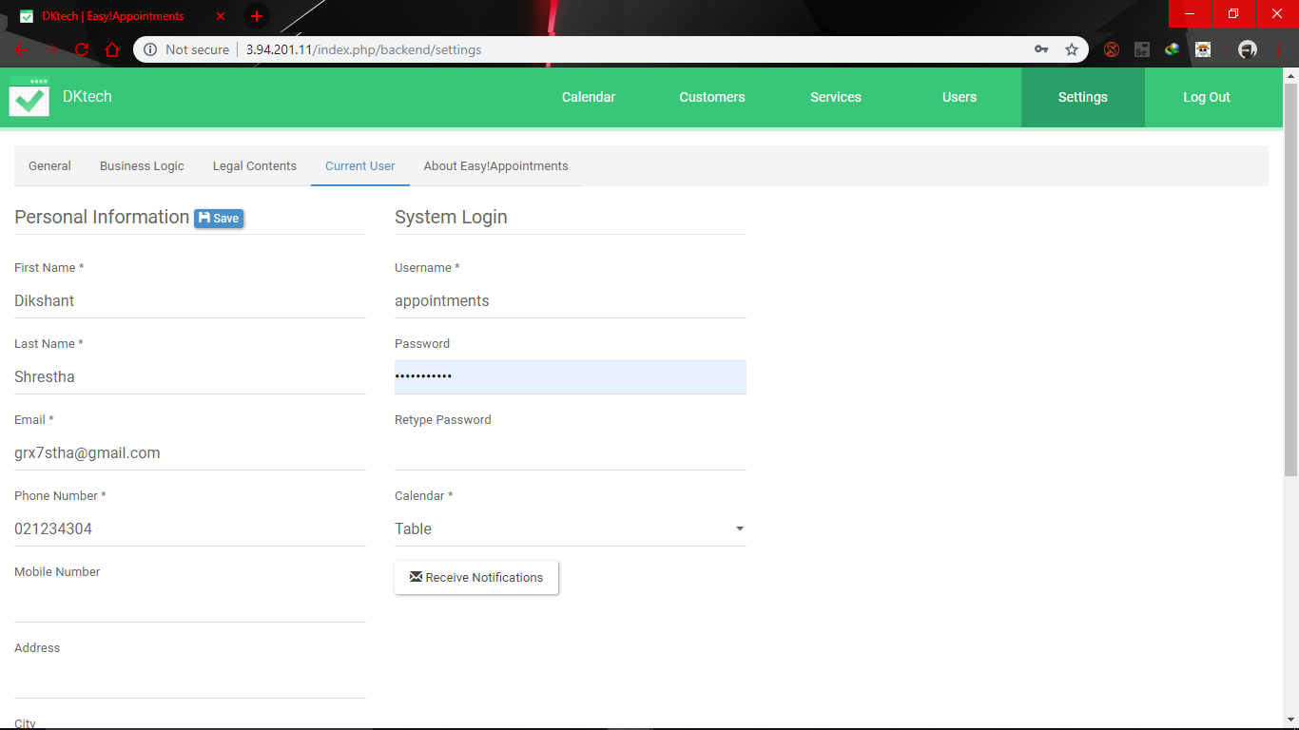

In it we type the new password in the password section and re type it in the retype password section

Then we press the save button to make the change.

Question 10

-

We can change the administrator details the same way we changed the administrator password

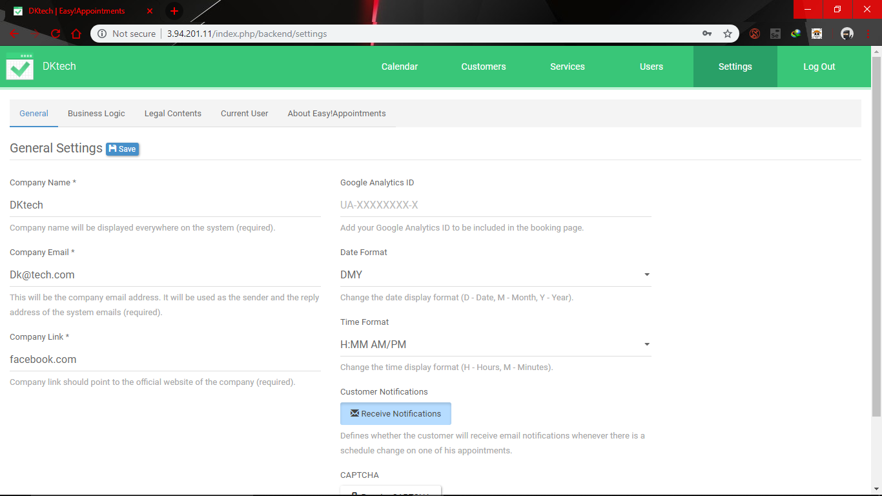

We go to the Settings menu and then we go to current user

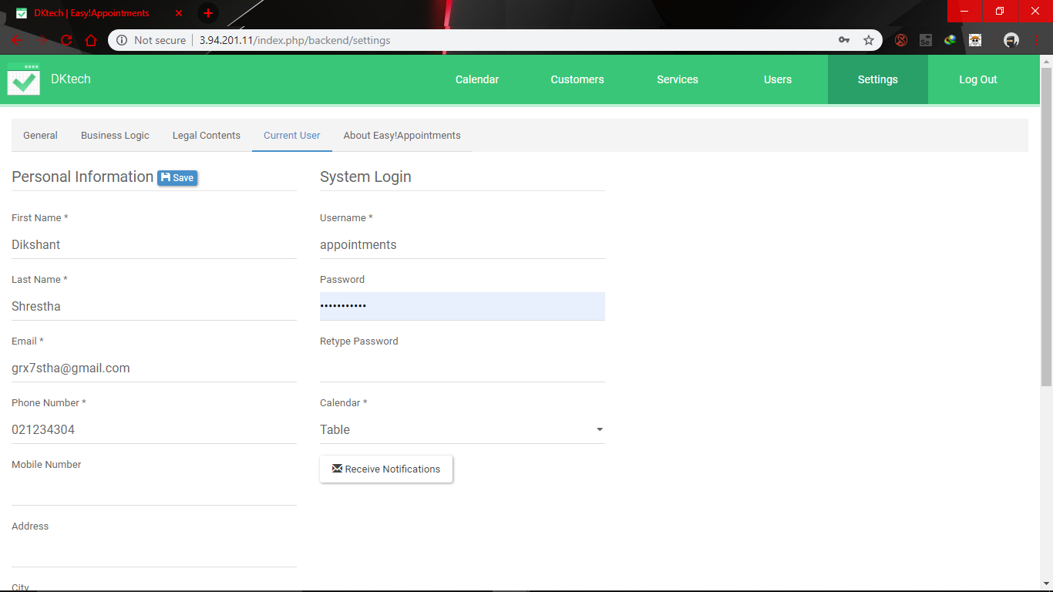

We can change the details from here and after that we can save it to keep the change.

Question 12

-

We can activate CAPTHA option from the settings menu and in the page we have the look like

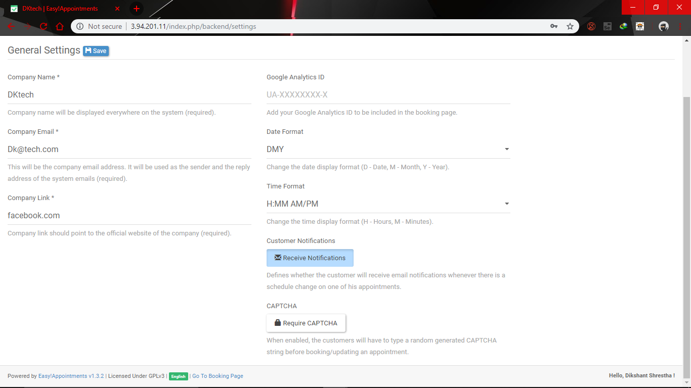

We just activate it by clicking on the Require CAPTCHA

And save it to keep change.

Question 14

-

We change the format of time and date from the setting tab on the backend section

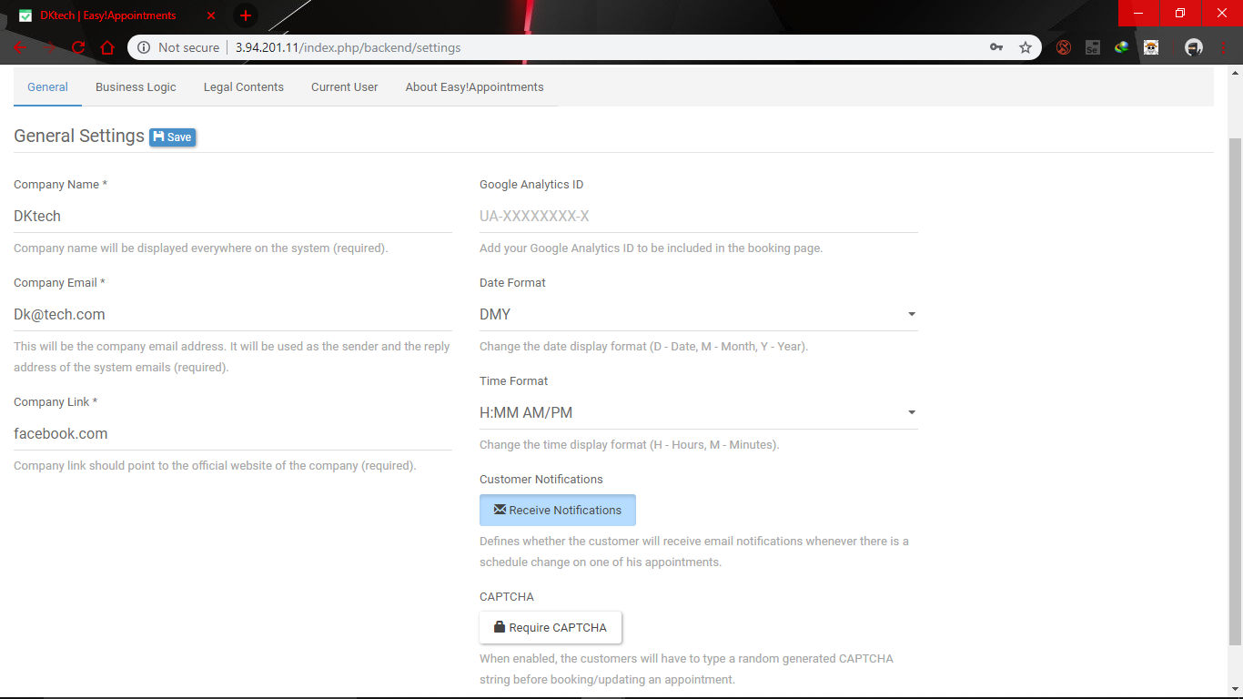

And then we chose the date format and time format to change them and save it.

Question 16

We can conform our customer details saved in the customer tab in the backend section and at the left corner. Like in the picture.

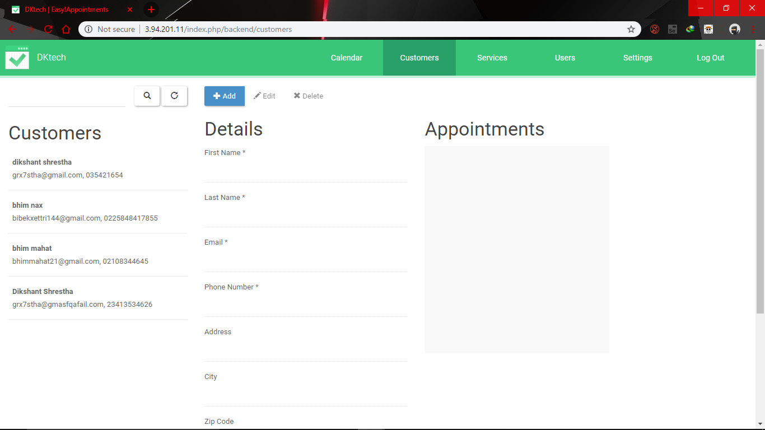

And we can check it from php y admin by going to it and logging in to it

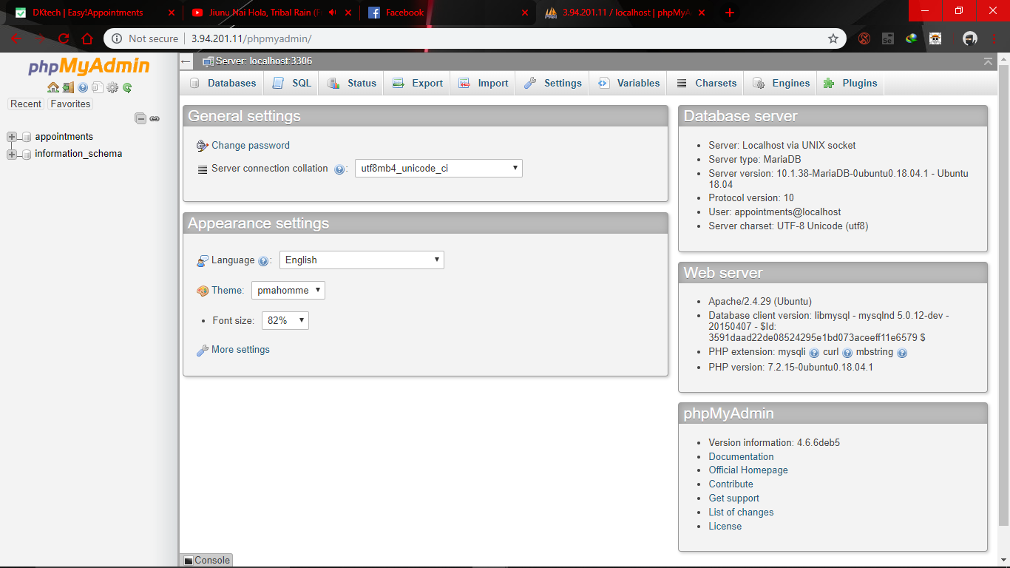

After that we go to appointments to left corner

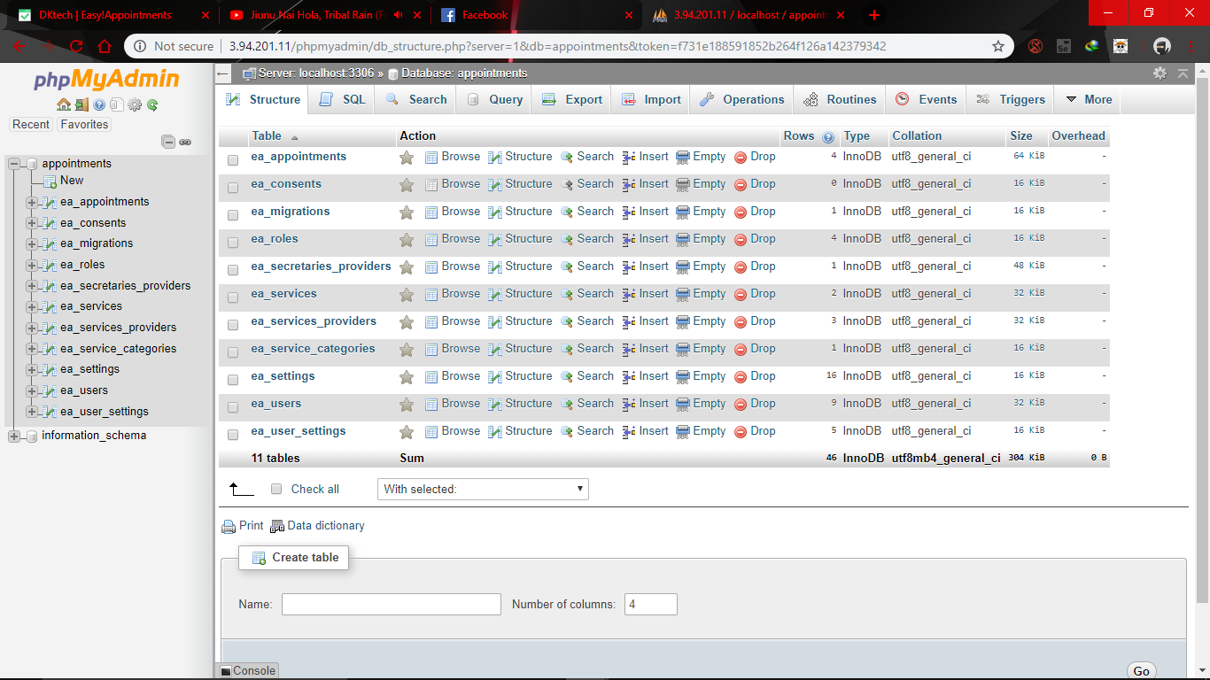

**Then again at the left corner we go to the ea_users and from there we can check it.**

Question 18

-

We can edit our details from the backend section by going to the

Settings page and then we can edit our details on it.

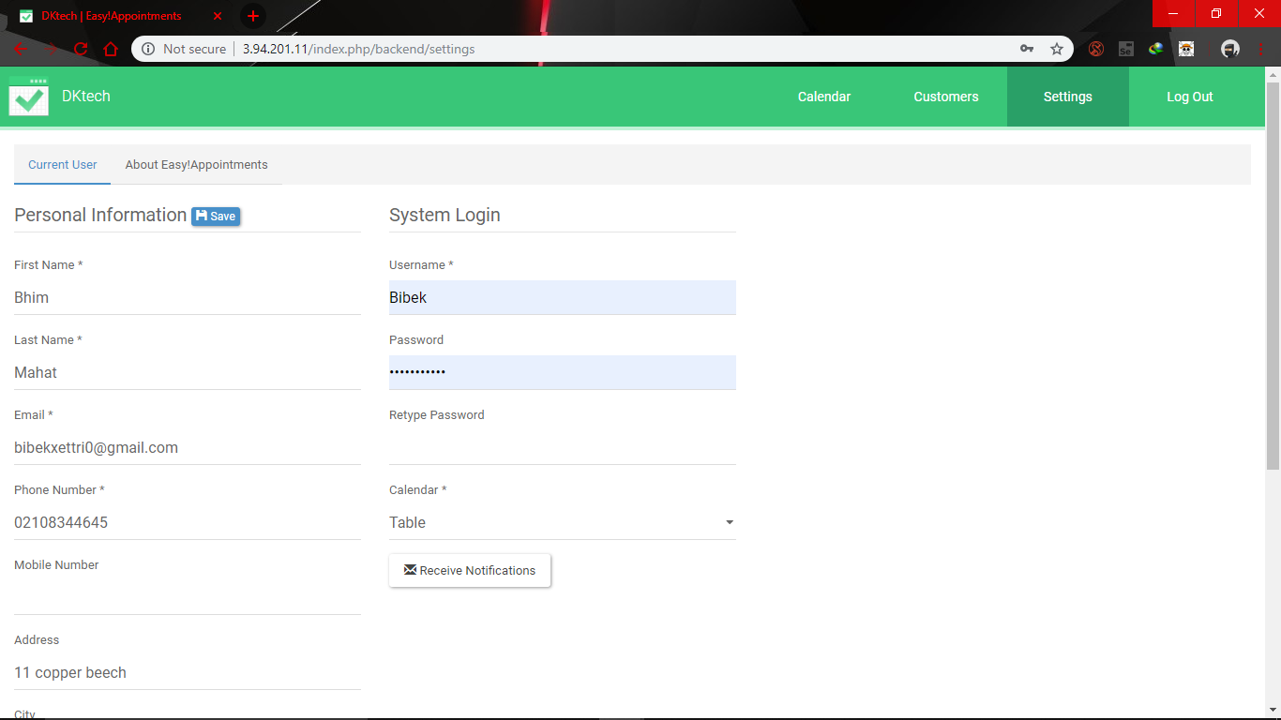

After changing our details, we can keep the change by pressing the save button.

Question 20

-

We can edit and save our cookie, terms and conditions and privacy policy from the setting

Menu and in the Legal Content tab.

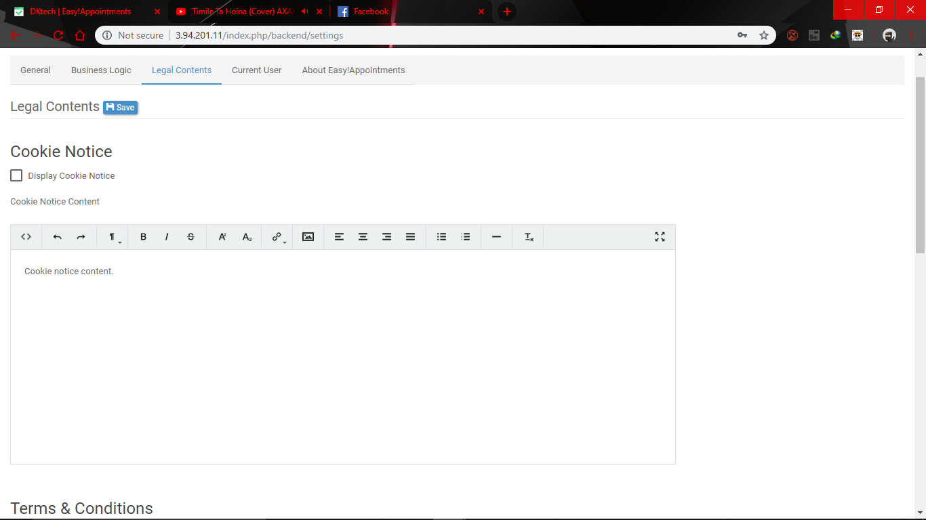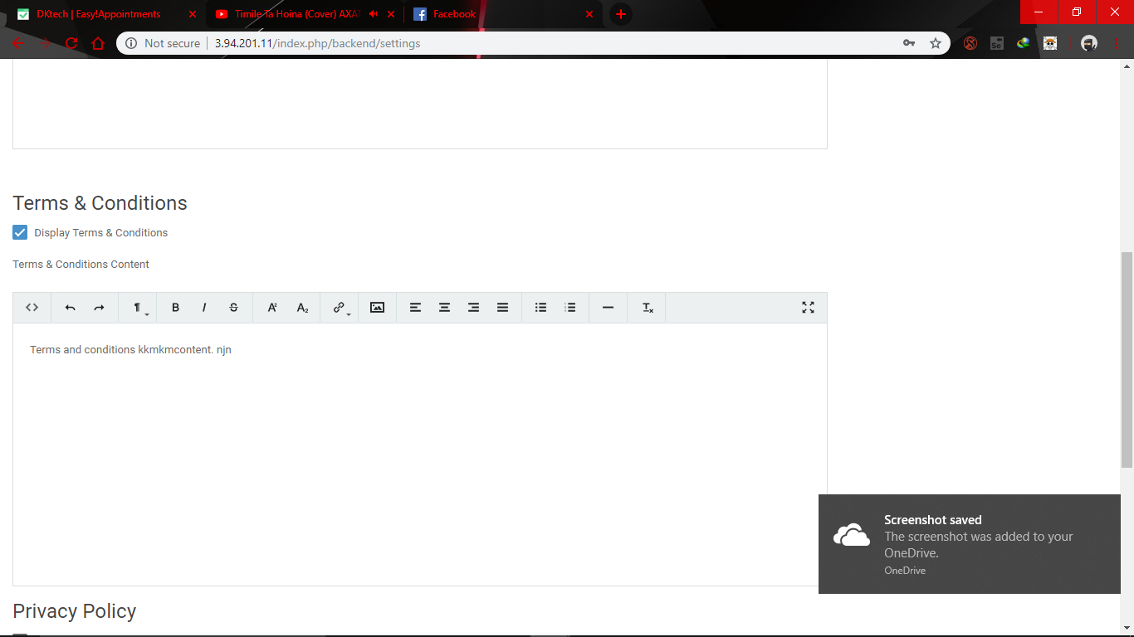

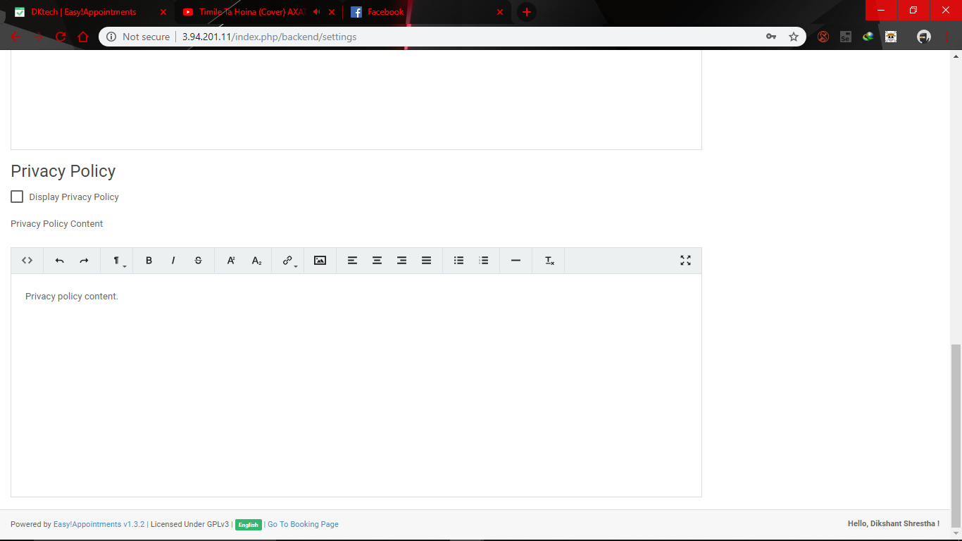

Question 22

-

We can add categories from the Service Menu.

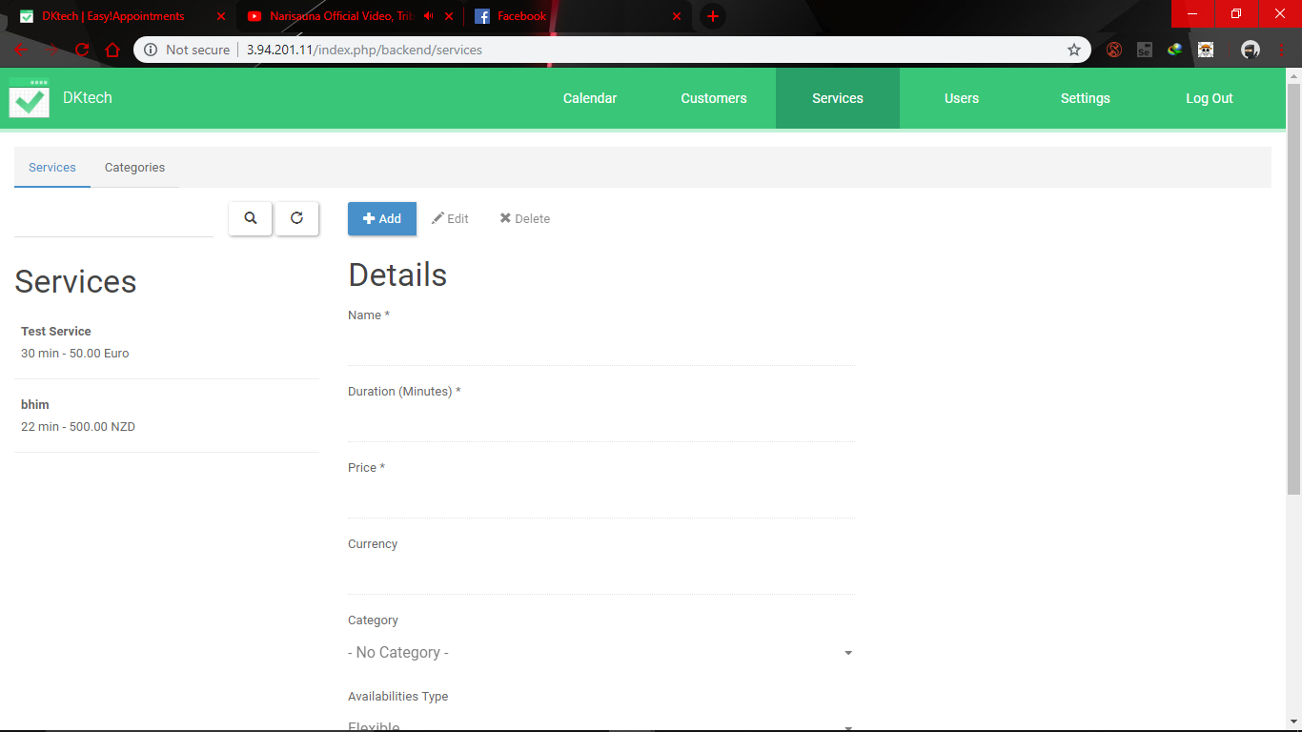

And we go to category

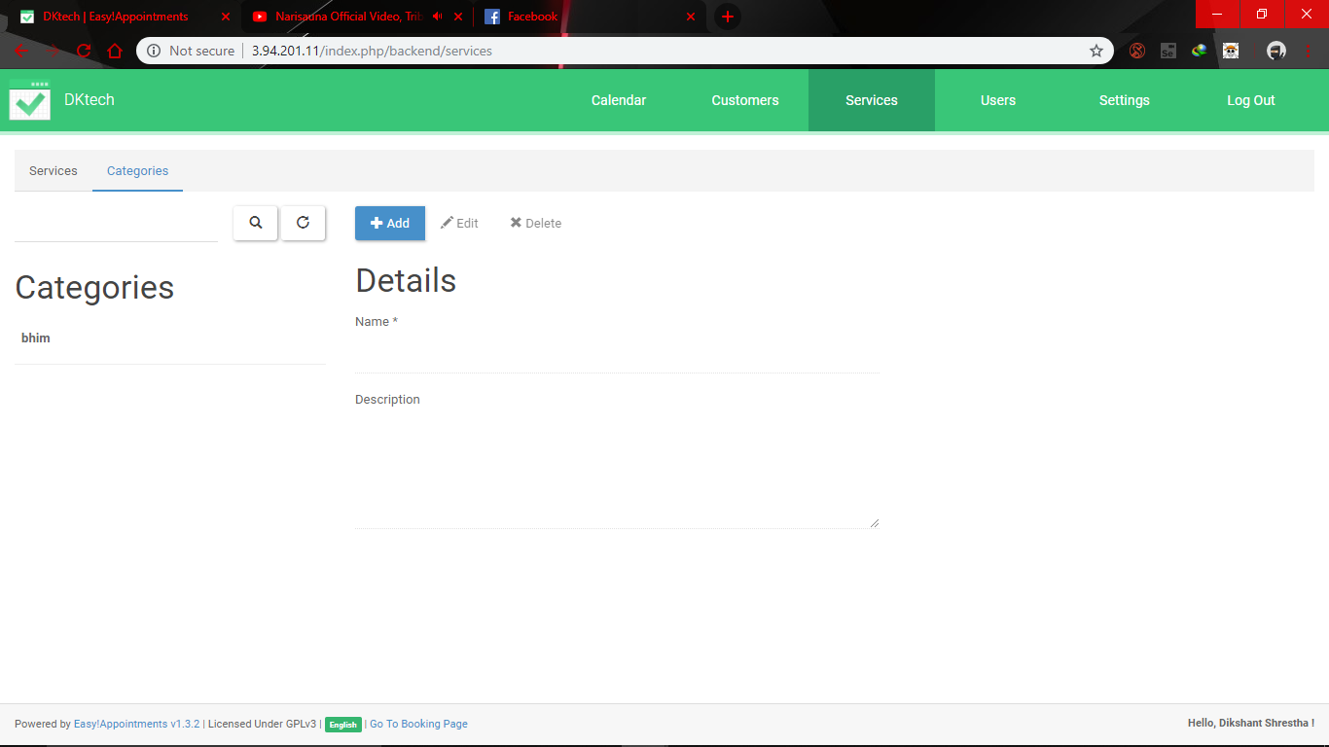

Now click + Add and we fill the details and add it .

Question 23

-

To add unavailable time period in backend section we need to go to the calendar section and click + Unavailable

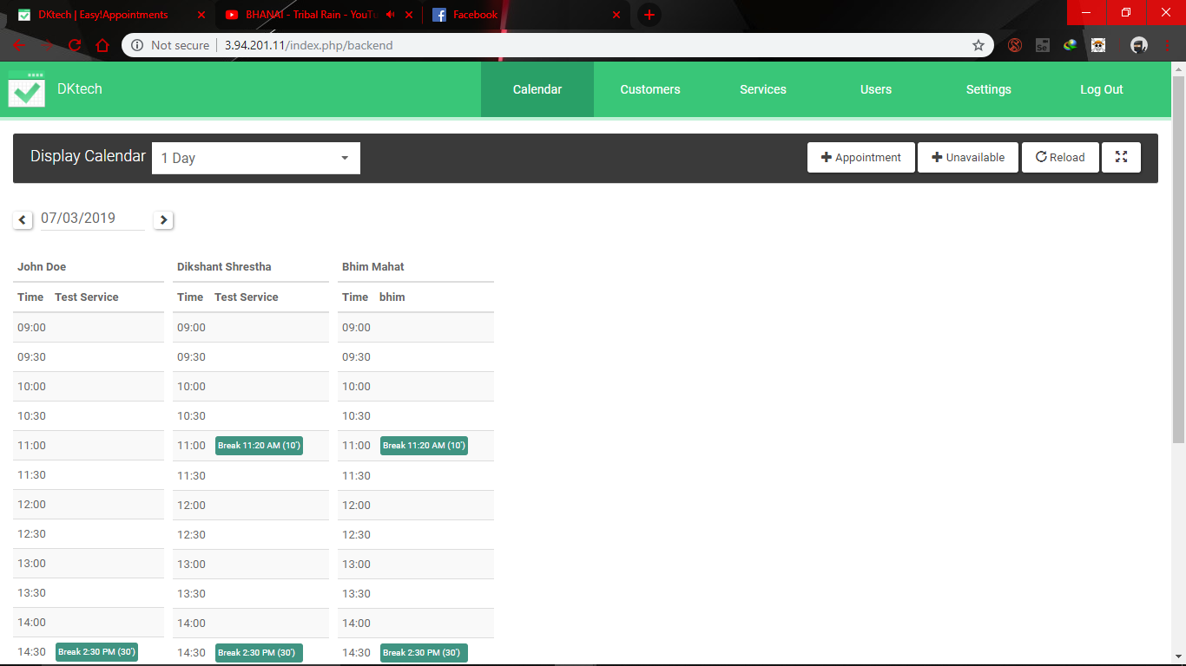

And we chose the time and date we won’t be available.

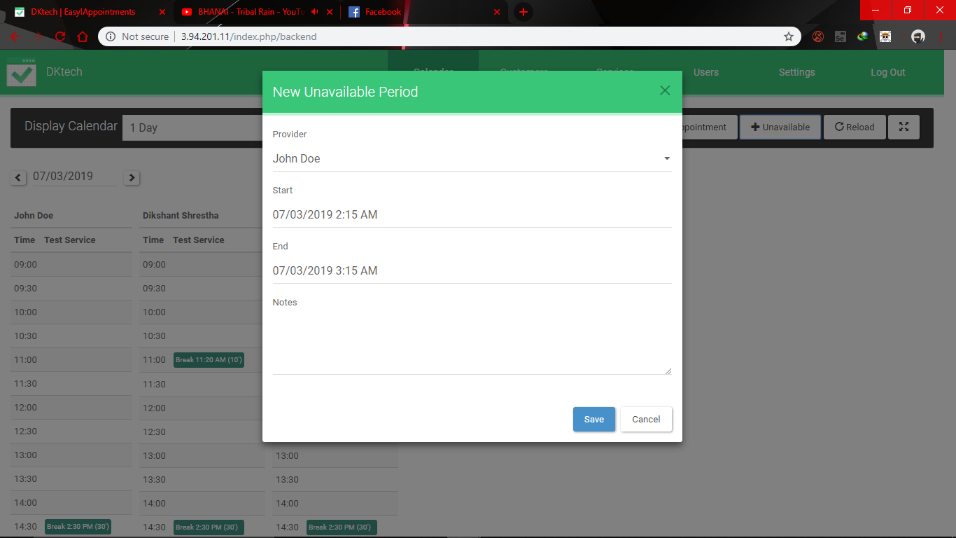

And we save it .